AFRICAN WOMEN IN MATHEMATICS ASSOCIATION (AWMA)
The African Women in Mathematics Association (AWMA) organized a workshop 16th-18th July 2015 at Naivasha in Kenya. This workshop, on the theme “Women in Mathematics for Social Change and Sustainable Livelihoods”, gathered 43 participants coming from various African countries and also France.
This workshop was a follow-up to a series of workshops jointly organized by AMUCWMA (African Mathematical Union Commission on Women in Mathematics in Africa) and CIMPA (International Centre for Pure and Applied Mathematics). The first was held in Ouagadougou Burkina Faso, 26th–27th October 2012, and the second at the African Institute of Mathematical Sciences (AIMS), Cape Town South Africa, 17th – 19th July 2013.
AWMA’s first General Assembly was held during the Naivasha workshop. The aims were multiple: to adopt the report of activities of the period 2013/2015, to adopt the logo of AWMA and to approve the new website of AWMA. From now on, AWMA has a logo designed by Ms Milaine Sergine Seuneu Tchamga, the Publicist Secretary of AWMA and
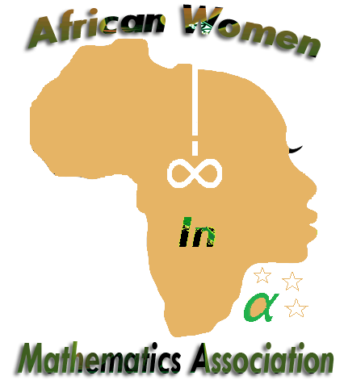
a website located at http://africanwomeninmath.org/. This website is financed by the IMU’s Committee for Women Mathematicians (see below), and was created by a specialist webdesigner who also designed the EWM (European Women in Mathematics) website. On it one can find the reports of past workshops, the constitution of AWMA, and other information on African Women Mathematicians.
The creation of AWMA was first discussed at the workshop of Ouagadougou in 2012. This came to fruition at the workshop held at AIMS, Cape Town where the AWMA Constitution with twenty articles was formed and adopted during a round table.
Since Mathematics is considered to be the mother of all Science and Technology, the main aim of AWMA is to bring together women from various countries within the African continent to give them a platform for presenting their work, discuss the situation and status of women in mathematics in each of their countries, and to update the data on African Women in the Mathematical Sciences. In order to contribute to increasing the skills of the human capital capacity of the African continent it is critical to realize the importance of promoting mathematics amongst the African population. However the number of mathematicians in Africa is small, moreover the proportion of women among them is extremely low. For this reason AWMA was formed to contribute to the development of mathematics and women in mathematics.
The main tool for implementing the Association’s statutory goals is the general meeting. Thus AWMA has a general meeting at least once every two years. The general assembly is held during the general meeting.
The Officers of the Association are the President, five Regional Vice Presidents one from each region of Africa, the Secretary, the Vice Secretary, the Treasurer and the Publicity and Information Officer. The Officers of the Association is elected at the General Meeting by a secret ballot. They take office for four years. A member may be eligible for another term of office but no member may serve at the same post for more than two consecutive terms. The standing committee is composed of the Officers.
Since its foundation, AWMA has been involved in various activities:
1. Participation in the EWM general meeting: AWMA was invited to participate in the 16th general meeting of EWM (European Women in Mathematics) which took place 2nd-6th September 2013, in Bonn, Germany. AWMA representatives at this congress were Prof. Josephine Guidy-Wandja, Vice-president for Western Africa and Prof. Yirgalem Tsegaye, Vice-president for the Eastern region.
2. Participation in ICWM: AWMA was invited to participate in ICWM 2014 (International Congress of Women Mathematicians) held 12th -14th August 2014 in Seoul, South Korea. The president of AWMA was a member of the ICWM-forum which took place during the panel session “Mathematics and Women: Different Regions, Similar Struggles”. The panel had 8 participants from all parts of the world. More than twelve members of AWMA attended the ICM (International Congress of Mathematicians), thanks to NANUM together, the grant proposed by South Korea which enabled 1000 participants from developing countries to attend the ICM.
3. CWM group: In order to prepare and organize ICWM 2014, a committee «WiM: Women in Mathematics» was created by IMU (International Mathematical Union). This committee created webpages http://www.mathunion.org/cwm/home/ whose aim is to promote women mathematicians, and to coordinate associations of women mathematicians internationally under the auspices of the IMU. After ICWM 2014, IMU EC established a Committee for Women in Mathematics (see the Terms of references of IMU CWM on the above website). The president of AWMA is a member of CWM.
The establishment of AWMA has led to the creation of women in mathematics associations in several countries:
-Association des Jeunes Femmes en Mathématiques (AJFM): December 2013
-Nigerian Women in Mathematics (NWM): July 2014
- Kenyan Women in Mathematical Sciences (KWIMSA): November 2014
-Association of Congolese women in Mathematics and Computer Science (AFCMC): December 2014
-Tunisian Mathematician Women Association (TMWA): 2015

Here is the standing committee of AWMA from 2013 to 2017.
President: Dr Marie Francoise Ouedraogo (Burkina Faso)
Vice President - West Africa: Professor Joséphine Guigy-Wandja (Côte D’Ivoire)
Vice President - Central Africa: Professor Rebecca Walo Omana (D.R. Congo)
Vice President - North Africa: Dr Schehrazad Selmane (Algeria)
Vice President - East Africa: Professor Yirgalem Tsegaye (Ethiopia)
Vice President - Southern Africa: Professor Sibusiso Moyo (South Africa)
Secretary: Professor Senelani Dorothy Hove-Musekwa (Zimbabwe)
Vice Secretary: Mrs Winniefred Mutuku (South Africa/Kenya)
Treasurer: Dr Fagueye Ndiaye (Senegal)
Publicist Secretary: Ms Milaine Sergine Seuneu Tchamga (South Africa/Cameroon)

For more information about AWMA, see our website or contact Marie Francoise Ouedraogo: omfrancoise@yahoo.fr

