Invitation Request Form

To request a letter of invitation, please send this Invitation Request Form after filling it out and a copy of passport to the secretariat by e-mail (icme12@icme12.org).

* NOTE: An Invitation Letter will be sent to the email you provided after proof of registration has been confirmed by the secretariat. If you require your invitation to be delivered via courier, we will be happy to arrange this at your own expense.

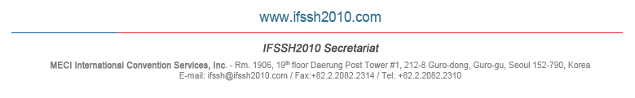
PERSONAL INFORMATION:

On-line Registration No.
Country
Affiliation
First Name
Last Name
Address
E-mail
Date of Birth (DD/MM/YYYY)
Passport Number
Length of Visit

I request to have a letter of invitation to attend the 12th International Congress on Mathematical Education to be held from 8th to 15th July, 2012 in Seoul, Rep. of Korea.

Date:
Name:

