 | 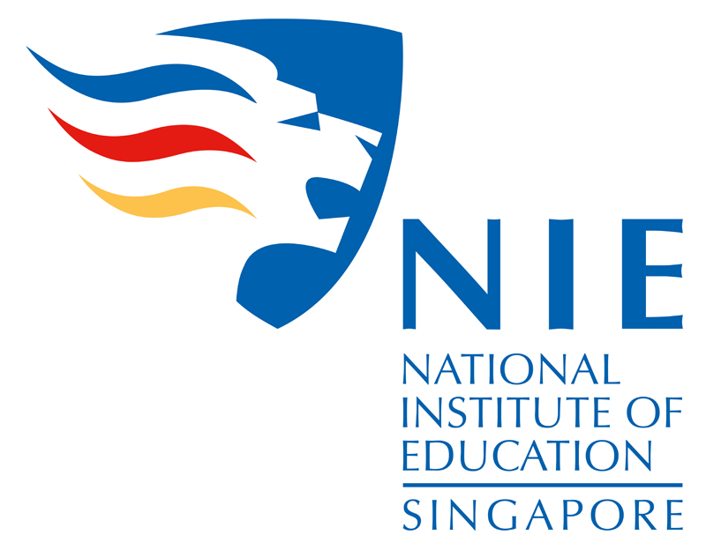 | 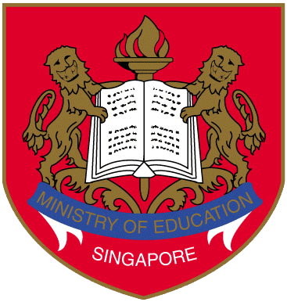 | 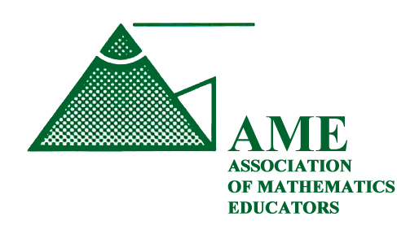
National Presentation at ICME 12
Mathematics Education in Singapore

Overview of Presentation

Introduction
The Singapore Presentation (SP) team will describe mathematics education in Singapore at ICME 12 which will be held in Seoul, Korea from 8 – 15 July 2012. The SP team comprises members from the National Institute of Education (NIE), Ministry of Education (MOE) in Singapore, and Association of Mathematics Educators (AME), Singapore. The members of the team are as follows:

Role | Name | Designation
Advisors | Professor Lee Sing Kong  Mrs Chua Yen Ching  A/P Toh Tin Lam | Director, National Institute of Education (NIE)  Director, Curriculum Planning & Development Division (CPDD), Ministry of Education (MOE)  President, Association of Mathematics Educators (AME)
Members | Professor Berinderjeet Kaur  A/P Wong Khoon Yoong  A/P Tay Eng Guan  A/P Ng Swee Fong  Ast/P Lee Ngan Hoe  A/P Jaguthsing Dindyal  Mrs Low-Ee Huei Wuan  Mr Soh Cheow Kian  Ms Yen Yeen Peng  Mr Zuhairi Mohd  Ms Gayatri Balakrishnan  Dr Yeo Shu Mei  Ms Loh Mei Yoke  Ms Tan Hwee Chiat, June  Ms Tan Lay Chin  Mrs Tan-Foo Kum Fong | Math & Math Education (MME), NIE & AME  Math & Math Education (MME), NIE & AME  Math & Math Education (MME), NIE & AME  Math & Math Education (MME), NIE & AME  Math & Math Education (MME), NIE & AME  Math & Math Education (MME), NIE & AME  AME  Curriculum Planning and Development Division, MOE  Curriculum Planning and Development Division , MOE  Curriculum Planning and Development Division , MOE  Curriculum Planning and Development Division , MOE  Curriculum Planning and Development Division , MOE  Curriculum Planning and Development Division , MOE  Curriculum Planning and Development Division , MOE  Curriculum Planning and Development Division , MOE  Master Teacher, The Academy of Singapore Teachers (AST), MOE

Presentation
The presentation will take place on Tuesday, 10th July 2012 from 3 – 4.30 pm and 5 – 6.30 pm.
The tentative schedule of the presentation is as follows:

Time | Topic | Presenters
3.00 – 4.30 pm | Mathematics Education in Singapore  Covering  - Brief introduction of Singapore’s Education System  - Designing a Mathematics Curriculum to Meet the Needs of Every Student  - Instructional Materials Development  - Support for Low Achievers and Programmes for the Gifted  - National Examinations  - Students’ Achievements in International Comparative Studies | Mr Soh Cheow Kian  Ms Yen Yeen Peng  Ms Loh Mei Yoke  Ms Tan Hwee Chiat, June  Ms Tan Lay Chin
4.30 – 5.00 pm | Coffee Break
5.00 – 6.30 pm | Teacher Preparation and Development and Mathematics Education Research in Singapore  Covering  - The NIE and Teacher Education  - Pre-service Education of Mathematics Teachers  - Professional Development of Mathematics Teachers  - Mathematics Education Research in Singapore | Professor Berinderjeet Kaur  A/Professor Tay Eng Guan  Ast/Professor Lee Ngan Hoe  A/Professor Wong Khoon Yoong  A//Professor Toh Tin Lam  Mrs Tan-Foo Kum Fong  A/Professor Ng Swee Fong
6.20 – 6.30 pm | Discussion  Chair: Professor Berinderjeet Kaur | All Presenters

After the presentation, participants may collect from the presenters
- a booklet on mathematics education in Singapore, and
- a special issue of journal (The Mathematics Educator) on Mathematics Teacher Education and Research in Singapore.
Synopsis of presentations

Mathematics Education in Singapore
Brief introduction of the Education System
This presentation gives an overview of the education system in Singapore and shows how it has evolved over time to meet the needs of the nation and to equip each individual with a strong foundation to live and work productively. The education system provides different pathways for students. The philosophy of providing “ladders and bridges” to meet the diverse educational needs of the students is key to the design and development of the mathematics curriculum.
Designing a Mathematics Curriculum to Meet the Needs of Every Student
Singapore has a national curriculum developed by the Curriculum Planning and Development Division (CPDD) in the Ministry of Education. The curriculum is reviewed regularly to ensure that it remains relevant and updated as well as to consider ways to improve the learning outcomes of the students. The different syllabuses and their design considerations are explained in the context of our education system and philosophical approach. The central focus of the mathematics curriculum is mathematical problem solving. This is encapsulated in the single mathematics curriculum framework that guides the development of all syllabuses.
Instructional Materials Development
Since the late 90s, MOE outsourced the development of instructional materials such as textbooks and workbooks to commercial publishers who would also manage the sales and distribution. CPDD ensures quality control by reviewing and vetting the textbooks and workbooks before approving them for use by schools. CPDD provides other supplementary resources and publications to guide and support teachers in implementing sound pedagogies and assessment practices.
Support for Low Achievers and Programmes for the Gifted
Special programmes and provisions are made to support students with difficulty learning mathematics as well as students who are gifted. The support for low achievers in Mathematics is carried out as early as Primary 1, where students are identified for ‘pull-out’ classes taught by specialist teachers. At the other end of the ability spectrum, the gifted programme ensures that the best are stretched. MOE has set up a specialized independent school called the National University of Singapore (NUS) High School for Mathematics and Science to provide a customised curriculum for students who are gifted.
National Examinations
There are national examinations at key stage years of Grades 6, 10 and 12. MOE works with the Singapore Examinations and Assessment Board (SEAB) and Cambridge International Examinations (CIE) to run the national examinations. At the end of primary 6, or Grade 6, all students will take a Primary School Leaving Examinations (PSLE). At the secondary and pre-university levels, there are the O, N and A-level examinations. Published items from these examinations will be shared to give an idea what is expected of students at every level.
Students’ Achievements in International Comparative Studies
Singapore has done well in international comparative studies such as TIMSS and PISA. The presentation will share some of the insights and learning gleaned from these studies and how they informed curriculum review and development.

Teacher Preparation and Development and Mathematics Education Research in Singapore
The NIE and Teacher Education
An autonomous institute within the Nanyang Technological University, the National Institute of Education (NIE) is the sole teacher education institution in Singapore. Globalization and the pervasiveness of digital technologies are the defining characteristics of our world at the turn of the 21st century. Learning and acquisition of values are directly impacted. The logical corollary “21st century learners call for 21st century teachers” became the impetus for NIE’s most recent institute-wide programme review and enhancement, which culminated in a new Model of Teacher Education for the 21st Century (TE²¹). We will briefly describe the 6 broad recommendations of TE²¹ that are intended to enhance the key elements of teacher education, with special emphasis on two of them, viz., the Values³, Skills and Knowledge model and the Graduand Teacher Competencies framework. Examples from Mathematics teacher education will be used for this ICME-12 presentation.
Pre-service Education of Mathematics Teachers
Pre-service education provides the crucial initial training that can have long-term impacts on the quality of future teachers in an education system. In Singapore, trainee teachers take mathematics-related courses called Curriculum Studies (methodology), Subject Knowledge (deeper understanding of school mathematics), and Academic Studies (tertiary mathematics). These courses are taught by the mathematicians, mathematics educators, and “mathematician educators” (those with expertise in both areas) who belong to the same department called Mathematics and Mathematics Education Academic Group. These courses stress rigour of mathematics contents and relevance to local school contexts and school mathematics, in particular, mathematics problem solving. Blended learning is used in response to the significant roles of ICT in teaching and learning as well as the changing characteristics of the trainee teachers. International benchmarking of the outcomes of NIE pre-service teacher education will be discussed using findings from IEA’s Teacher Education and Development Study in Mathematics (TEDS-M).
Professional Development of Mathematics Teachers
In Singapore the Ministry of Education develops her practicing teachers into life-long learners through emphasis on professional development of teachers after completing their initial teacher training. This is so as the educational landscape is rapidly changing to meet both the needs of the nation and the challenges of the international landscape. Teachers have different pathways to upgrade their knowledge and skills through Professional Development Continuum Models (PDCM). We will describe how the Ministry of Education (MOE), National Institute of Education (NIE) and professional organizations for mathematics teachers, such as the Association of Mathematics Educators (AME), support practicing mathematics teachers’ professional development through their programmes and activities respectively.
Mathematics Education Research in Singapore
This presentation will provide participants with a glimpse of mathematics education research in Singapore. Research is undertaken by graduate students, and university academics. Since 2002, the Ministry of Education, through the Office of Education Research (OER) at NIE has funded research that may inform policy and practice so as to improve education in Singapore. We will showcase some research projects that have had a significant impact on the teaching and learning of mathematics in Singapore schools.

Exhibition – i/c Mrs Low-Ee Huei Wuan & A/P Jaguthsing Dindyal
Exhibits – books, manipulatives (MOE).
Posters – Approximately 20 size A1 (60 cm by 84 cm) showcasing specific aspects of math education and research in math education in Singapore.

