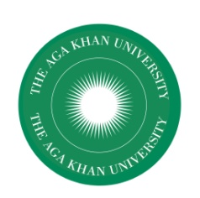
AGA KHAN UNIVERSITY
Institute for Educational Development, East Africa
Salama House, 344 Urambo Street
P.O. Box 125
Dar es Salaam, Tanzania

AFRICME 5 CONFERENCE
AUGUST 29-31, 2018
APPLICATION FOR ACCOMODATION IN
STUDENT HOUSING

- Name:
- Gender (Male/Female):
- Qualification:
- Institutional Affiliation:
- Country:
- Address (permanent):
Telephone Number:
Email Address:
- Check in date (28th August 2018 or after)
- Check out date (before 2nd September 2018)
- Any special requirements (please specify):
- Payment Options (tick as appropriate)
Self

Applied to AFRICME5 Support Fund (subject to availability)

Registration can be sent by email to:
Email: rosemary.stephen@aku.edu
Please note that accommodation does not include breakfast or any other meals.

