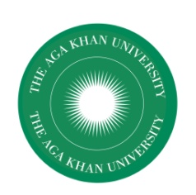
AGA KHAN UNIVERSITY
Institute for Educational Development, East Africa
Salama House, 344 Urambo Street
P.O. Box 125
Dar es Salaam, Tanzania

AFRICME 5 CONFERENCE
AUGUST 29-31, 2018

REGISTRATION FORM

- Name:
- Qualification:
- Institutional Affiliation
- Country
- Address:
Telephone Number:
Email Address:
- Attendee Type (Please Select below)
- International Delegate

- Local Delegate

- Student Local delegate

- Student International delegate

- Payment Options:

Cash (Pay on arrival)

Bank Transfer

Bank details
Account name: THE AGA KHAN UNIVERISTY
USD A/C: 0092897002
TZS A/C: 0092897001
Bank Name: Diamond Trust Bank
Swift code: DTKETZTZ

Registration can be sent by email to:
Email: rosemary.stephen@aku.edu

(a) Please note that if you are applying for grants from AFRICME5 Support Fund you will have to complete and return the separate application form for the grant by 15th June 2018
(b) If you wish to get student housing (either paying yourself or through the grant support) you will have to complete and submit the separate form for Application for Accommodation by 15th June 2018.

