Mathematics Education in Micronesia:

Building Local Capacity to Provide Professional Development

for Teachers of Mathematics

by

A. J. (Sandy) Dawson

University of Hawai‘i-Manõa
and
Pacific Resources for Education and Learning (PREL)

Honolulu, Hawai‘i
October 2004

Abstract This paper reports on two National Science Foundation (NSF) funded projects (DELTA and MENTOR) that are developing a new way of offering professional development to not only novice and experienced teachers of mathematics but also to the mentors of those teachers, all of whom reside on remote Pacific islands. The preparation of the mentors and the focus of their roles with teachers are described. Because of the work of the mentors, the ability of these remote communities to provide professional development for their own teachers is improving dramatically. The impact of the mentors on local teachers can be seen in the manner in which the teachers now approach the teaching and learning of mathematics in local classrooms. The impact of the local teachers on children can be seen not only in the improved test scores being achieved by the children, but also in the attitudes and beliefs teachers and children now hold regarding their ability to do mathematics. The paper addresses Strand II of the ICMI Study. In particular it focuses on what kinds of leadership help support teachers’ learning and what are crucial practices of learning from practice (central questions ‘d’ and ‘e’, p.18, ICMI Bulletin No. 54).
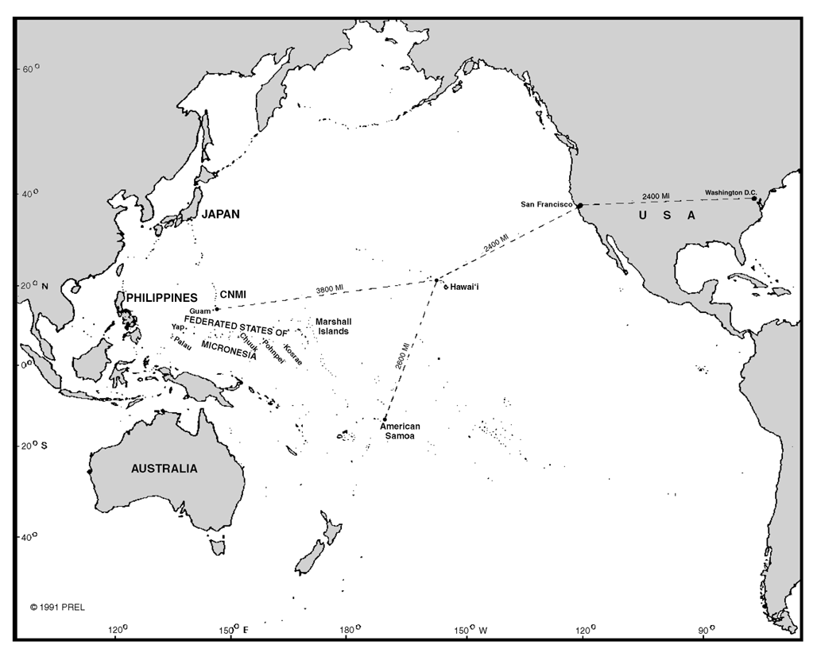
Imagine you are asked to assist with the preparation of mathematics educators who dwell in a region that encompasses a population of approximately 1.7 million people living on 110 islands spread across 4.9 million square miles of Pacific Ocean. To say the least, such a task presents unique challenges to even the most experienced professional development leader’s strategies and ways of working. What would you do?

Map showing distances across the Micronesian region

(Not to scale)

Imagine further that in addition to being geographically isolated, the region in which you are asked to work is characterized by high cultural and linguistic diversity, varying socio-political class and cultural structures, and with generally limited economic resources. This is the context within which the work discussed in this paper takes place. Taken alone each of these factors would have great impact on the nature and success of professional development initiatives introduced at the local or regional level. Taken together, these factors provided an opportunity to experiment with a new model for professional development that built local capacity and generated a cadre of home grown professional developers in mathematics education. The map shows the states and countries1 of the Pacific region where the work is taking place.
The work began September 1999 and is scheduled (and funded) through August 2007. It is rooted in critical social theory. This perspective acknowledges that classrooms are necessarily socio-cultural constructs where teachers work under societal and cultural constraints and dilemmas. The focus and nature of any professional development experiences undertaken, if they are to be relevant and meaningful to particular teacher groups, must respect local needs and priorities and accommodate the socio-cultural and political contexts in which teachers work.
The work is funded under two grants from the National Science Foundation. The first project, called DELTA (Developing Effective Leadership Training Activities), was a three year project that created professional development experiences designed and delivered by mathematics education leader/mentors familiar with the personal identities and socio-cultural realities of the local teacher community. The second project, called MENTOR (Mathematics Education for Novice Teachers: Opportunities for Reflection), is a five year enterprise that focuses on mathematics education leaders mentoring upwards of 500 novice teachers as they enter the teaching profession. The projects are sequential, and MENTOR is currently in its third year of operation.
Taken together, the two projects engendered a new way of offering professional development to not only teachers of mathematics but also to the mentors of those teachers. In doing so, the ability of remote communities to provide professional development for their own teachers improved dramatically. The impact of the mentors on local teachers can be seen in the manner in which the teachers now approach the teaching and learning of mathematics in local classrooms. The impact of the local teachers on children can be seen not only in the improved test scores being achieved by the children, but also in the attitudes and beliefs teachers and children now hold regarding their ability to do mathematics.
The ability of the Project to achieve its stated purpose of nurturing effective mathematics instruction in novice and experienced teachers is dependent upon the achievement of a number of goals, including but not limited to:
- developing experienced mathematics educators’ understandings of their roles and responsibilities of mentors, as well as of effective mentoring processes;
- developing experienced mathematics educators’ skills as mentors, as well as their abilities to design and implement professional development models that foster professional growth in teachers;
- increasing mentors’ and novice teachers’ mathematical content knowledge, as well as their understanding of associated pedagogy;
- increasing novice and experienced teachers’ ability to plan, implement and assess instructional sequences that reflect an understanding of the principles of standards-based mathematics learning and teaching;
- developing novice and experienced teachers’ and mentors’ abilities to reflect critically on their practices and on their growth as mathematics teachers and educators.
During the fall of 1999 each island community created a four-person mentor team comprised of a local college mathematics instructor, a college mathematics education instructor, the island community’s mathematics curriculum specialist, and an exemplary teacher of mathematics from the local school system. The composition of the team is unique to this project. In many cases team members had not previously worked or even spoken with other team members from their home communities. Teams grapple with the challenges and difficulties of building productive working relationships, adapt to meet local sensitivities regarding curricula and instructional practices (congruent with the Pacific mathematics standards) that they learnt during twice yearly mentor institutes, and then design and implement exemplary professional development activities for novice and experienced teachers of mathematics in their home communities.
Mentors assist teachers to identify, frame, and investigate problems related to the implementation of standards-based mathematics instruction. They investigate principles of effective professional development2 and design and deliver mathematics in-service programs that demonstrate these principles. At the same time, mentors are encouraged to carry out their own professional inquiries into the dilemmas and tensions inherent in the role of mentors on Pacific island communities. This blending of “external” knowledge3 with knowledge gained from practice acknowledges that powerful professional learning draws on sources from both inside and outside the learner and from both research and practice.
When mentor teams meet together during regional institutes they are provided with sustained professional development experiences to broaden and deepen their knowledge of 1) mathematics content and pedagogy, 2) standards-based curriculum, 3) the educational change process as it relates to implementation of standards-based instruction, and 4) effective professional development practices. Mentors continue to develop the skills necessary to design and implement relevant, effective, and socio-culturally appropriate mathematics professional development for teachers in their local communities. The teams are responsible for designing and implementing professional development experiences for teachers of mathematics that incorporate content knowledge, pedagogy, effective evaluation and assessment strategies, and for generating adaptive strategies for localizing instructional materials.
The focus of the mentors’ work during the 1999-2002 period was with experienced teachers of mathematics particularly at the middle school level. Beginning in the fall of 2002, their attention shifted to a primary focus on novice teachers. The mentors’ program for novice teachers weaves together three different types of experiences: summer institutes, in-class observations, and monthly professional development sessions.
Mentor teams design and conduct annual five-day summer institutes for novice teachers to develop their mathematics content knowledge, as well as their knowledge of standards-based mathematics pedagogy. Each institute focuses on a different mathematics content area, thereby ensuring that novice teachers receive instruction in selected areas (number and number operations, geometry and measurement, probability and data analysis) of the mathematics curriculum. The summer institutes provide a forum for novice teachers to experience mathematics learning, build their content knowledge, examine their assumptions and beliefs about mathematics learning and teaching, and critically examine the new vision of mathematics learning and teaching articulated in national, regional, and/or island standards.
In-class observations allow mentors to work individually with novice teachers in their classrooms on the implementation of standards-based instructional practices. These observations are structured to incorporate 1) a pre-teaching discussion, in which novice teachers clarify lesson goals and objectives, explain teaching strategies and activities, outline indicators of student achievement, and negotiate with mentors the focus for data gathering; 2) a teaching component, in which mentors gather agreed upon classroom data, observe evidence of student learning and note teaching strategies and 3) a post-teaching discussion in which novice teachers reflect on and summarize their impressions of the lesson, analyze classroom data, infer relationships between student learning and selected teaching strategies and interventions, and identify future goals4. The overall aim of the three-part observation cycle is to develop novice teachers’ abilities to reflect critically on their practices and to implement instructional sequences that align with the principles of standards-based mathematics learning and teaching.
Mentors also organize lesson study sessions on the specific curricular area explored in the previous summer institute. Lesson study, a professional development model that originated in Japan, promotes thoughtful inquiry into teaching and learning by having groups of teachers work collaboratively to design lessons for key mathematical concepts5. Lesson study, with its focus on examining genuine problems of instructional practice related to specific classroom contexts, is a powerful mentoring tool for novice teachers. It engages them in sustained conversations of how to plan effective standards-based learning experiences for key mathematics concepts, exposing them to different points of view and perspectives. It also fosters reflective practice, encouraging novice teachers to implement planned learning experiences, reflect on the effectiveness of the learning that has occurred, and identify areas for subsequent improvement. Finally, it provides a forum for mentors to explore with novice teachers key issues in mathematics pedagogy, including but not limited to questioning that promotes critical thinking and mathematical reasoning; teaching from a problem solving perspective; using manipulatives, computers, and calculators effectively; designing rich investigative tasks; promoting mathematical communication and discourse; and making connections across the curriculum.
Novice teachers in the Project receive sustained support for three years as they progress through an annual cycle of summer institutes followed by semesters of focused in-school support including classroom observations, monthly workshops, and lesson study. Over the five-year span of the Project, each mentor team works with 50 novice teachers, for a total of 500 mentored novice teachers across the Pacific region.
Each group of novice teachers on one of the island communities remains with the Project for three years. As shown in Table 1 below, group one is composed of a maximum of 12 novice teachers who are with the Project between 2002 and 2005. Group two is composed of a maximum of 16 novice teachers who are with the Project between 2003 and 2006. Group three is composed of a maximum of 22 novice teachers who began with the Project September 2004.

 | 2002/3 | 2003/4 | 2004/5 | 2005/6 | 2006/7
Group One | 12→ | 12→ | 12
Group Two |  | 16→ | 16→ | 16
Group Three |  |  | 22→ | 22→ | 22
Total per year | 12 | 28 | 50 | 38 | 22

Table 1: Size of Novice Teacher Groups by Year for Each Island Community

Data used to ascertain the impact of the Project on mentors, novice and experienced teachers, and their students are gathered using pre-post mathematics content tests, pre-post belief and attitude questionnaires, individual and group interviews, videotapes of teachers’ classrooms, data from observations made by project staff and consultants and test score data of the teachers’ students. The evidence collected thus far presents a strong case that mentors and teachers have grown in their understanding and effectiveness in implementing standards-based instruction. Moreover, their Pacific island students are improving their test scores.
The mentors came together in 1999 with high hopes, but with the knowledge that regional projects across the Pacific had not experienced great success in the past. They are the ones who changed that history. They melded themselves together into functioning professional development teams, they are engaging others from their local educational community in an enriched study of the teaching and learning of mathematics, and they are gaining the respect of their peers and supervisors in the process. Because they are successful, the project is successful.

 The communities involved are the state of Hawai‘i and nine U.S.-affiliated Pacific island communities: American Samoa, the Commonwealth of the Northern Mariana Islands (CNMI), the Federated States of Micronesia (FSM—Chuuk, Kosrae, Pohnpei, and Yap), Guam, the Republic of the Marshall Islands (RMI), and the Republic of Palau (Palau).
2 Loucks-Horsley, S., Hewson, P. W., Love, N., & Stiles, K. E. (1998). Designing professional development for teachers of science and mathematics. Thousand Oaks, CA: Corwin Press.
 Loucks-Horsley, S., Hewson, P. W., Love, N., & Stiles, K. E. (1998). Designing professional development for teachers of science and mathematics. Thousand Oaks, CA: Corwin Press.
 Costa, J., & Garmston, R. (1994). Cognitive coaching: A foundation for Renaissance schools. Norwood, MA: Christopher-Gordon Publishers.
 Lewis, C. (2002). Lesson study: A handbook of teacher-led instructional change. Philadelphia: Research for Better Schools. Lewis, C., & Tsuchida, I. (1998). A lesson is like a swiftly flowing river: How research lessons improve Japanese education. American Educator, 22(4), 12-17 & 50-51.

