Communicating “Own Strategies” in Primary Mathematics Classrooms:

Insights for Pre-service Teachers

Andrea Peter-Koop
Institute of Mathematics
University of Oldenburg (Germany)
peter-koop@mathematik.uni-oldenburg.de

Bernd Wollring
Faculty of Mathematics
University of Kassel (Germany)
wollring@mathematik.uni-kassel.de

Summary
The proposed demonstration addresses an important and frequently neglected issue with respect to the preparation of primary mathematics teachers, i.e. how to foster the articulation and communication of mathematical concepts and ideas in a constructive learner focussed mathematics classroom. In this context, the inclusion of non-verbal communication strategies, for example in forms of “iconic texts” will be explored and critically examined. This approach seems to deserve special attention in teacher preparation, because in traditional approaches, the communication of mathematical ideas in the classroom as well as during teacher training courses is frequently limited to verbal or written explanations of one’s own strategies. However, this approach presents a clear disadvantage for children who for various reasons (e.g. young age, language of instruction is not the mother tongue, individual problems with speech development) experience problems with the oral and written articulation of their mathematical understanding, ideas and strategies.
The proposed session, which addresses teachers as well as teacher educators and researchers, will provide various examples of mathematical working environments in which “iconic texts” are used to communicate the construction of meaning and understanding of mathematical concepts. These examples originate from teacher methods courses as well as primary classrooms in the Czech Republic, Germany and the United Kingdom. The context is the COSIMA project, a 3-year international Socrates Project funded by the European Union that aims to foster the communication of “own strategies” (German: Eigenproduktionen) in primary mathematics teacher education. While it is the deliberate goal of this project to bring to the attention of pre-service teachers that creating personal languages is an essential part of mathematical activity and thus should be an essential part of mathematics teaching and learning, the international context of the project provides unique opportunities for communicating mathematical meaning independent from the mother tongue. Based on innovative working environments from different areas of primary mathematics and respective artefacts from classrooms and methods courses, these issues will be highlighted and critically examined.
The participants will be provided with authentic examples of pupils’ as well as student teachers’ articulations of mathematical understanding and ideas and their communication with peers in their own classroom/course as well as in their foreign partner schools. Participants will be invited to experiment with different communication focussed learning environments and encouraged to explore, analyse and critically discuss the potential of this approach for primary mathematics teacher education in an international setting.
Proposal
The proposed demonstration addresses Strand I of the Study focussing on section e) by highlighting a special problem of teaching and learning primary mathematics – the communication of mathematical ideas and strategies in the classroom – and introducing the development of mathematical learning environments that foster the articulation and communication of mathematical ideas through “iconic texts”.

Theoretical Background
Current international research in mathematics education suggests that the effectiveness of teaching and learning mathematics will improve by changing traditional teacher centred educational strategies to constructive learner focussed approaches. This can be realised by a new classroom communication style with a stronger focus on
- creative thinking,
- construction of meaning,
- own strategies by the learners (German: Eigenproduktionen)
and consequently the profound extension of their communicative tools.
In other words, an essential element of a constructivist classroom is to support the mathematics related communication between the teachers and the pupils and also between the pupils themselves. At least in teacher education programs in Germany, this aspect has been largely neglected in the traditional methods courses.

Psychological research as well as classroom experience also suggest that, especially with young children, (mathematics related) action seems to precede the ability to express one’s own (mathematics related) thoughts, ideas and strategies in words. Thus, it can be argued, that new approaches can be substantially supported by the use and development of non-verbal languages with respect to the communication about shape, number and structure in the primary mathematics classroom. From our point of view, mathematics yields special communication platforms with respect to functional communication – especially through the exploration of various iconic forms of articulation and communication, such as children’s drawings or folding posters (see below).

The communication of pupils’ own strategies in various ways is also the focus of the 3-year Socrates-Comenius 2.1 project COSIMA funded by the European Union which commenced in October 2003 and involves four universities and four partner schools in the Czech Republic (Charles University, Prague), Germany (University of Kassel and University of Oldenburg) and the United Kingdom (University of East Anglia, Norwich). This project is concerned with the design of classroom materials to structure working environments which prepare student teachers as well as classroom teachers to motivate, moderate, record and analyse classroom communication about shape, number and structure. In this context, the international cooperation provides unique tools to analyse the structure and efficiency of the children’s communication, as their “mathematical messages” are also exchanged with children in foreign countries and therefore facilitate correspondence about mathematics beyond the boundaries of the mother tongue. Scientific analyses of pupils’ artefacts by “student teachers as researchers” (Peter-Koop & Wollring 2001) are currently in preparation.

Demonstration of Mathematical Working Environments
During the proposed session different examples of mathematical working environments that have been developed in the COSIMA project will be presented and discussed. These examples illustrate how the communication of mathematical ideas can be supported by different forms of iconic articulation. The context of the two examples below is the exploration of geometrical concepts through paper folding activities. The pictures show two “folding posters” (German: Faltplakate) designed by German fourth graders (on the left) and student teachers from a geometry course at the University of Kassel (on the right). The idea was to provide a folding instruction for second graders that would work without further oral explanation. The two folding posters illustrate in how far the fourth graders as well as the student teachers communicate key construction ideas which are related to the special properties of the object – in this case a star which is made out of two congruent but symmetrically opposite parts.
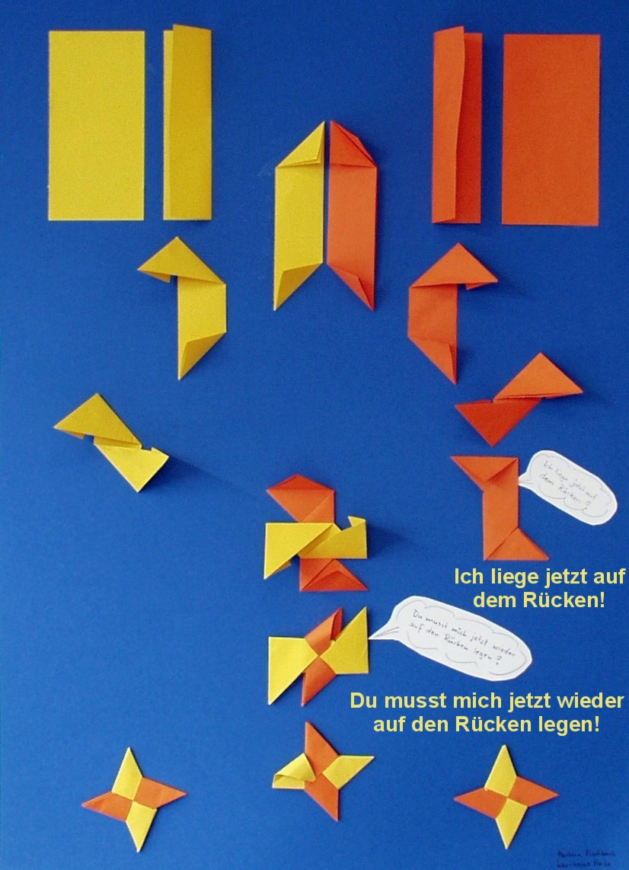
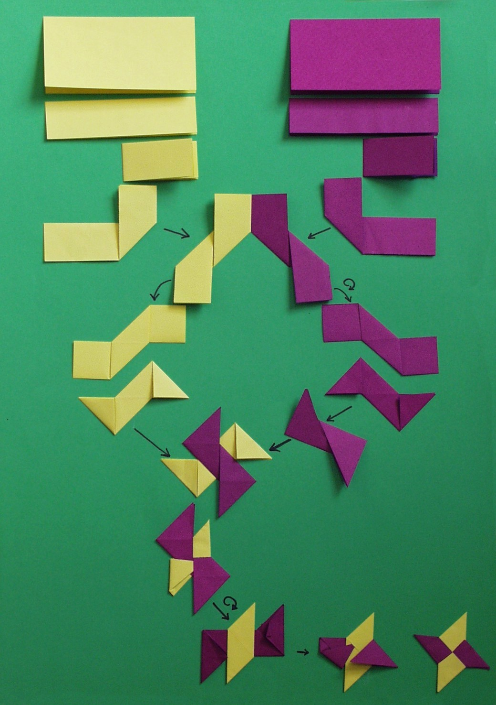

Translation of the pupils’ comments:

“Now I am lying on my back!”

“You have to put me on my back again!”

Anecdotal data from classrooms and teacher education courses in the three participating countires, in which artefacts from other countries have been used to foster the communication of mathematical concepts, will be provided. Furthermore, examples for learning environments that involve new information technologies as a tool for authentic communication about mathematical concepts and ideas and pupils’ as well as student teachers’ respective understanding and its articulation will be introduced.

Goals of the Session

The proposed session seeks to contribute to the 15th ICMI Study “The Professional Education and Development of Mathematics Teachers” in the following ways:
Firstly, the idea of non-verbal articulation and communication strategies will be
outlined with respect to its potential for the preparation of primary teachers within a constructivistic mathematics teacher education paradigm.
Secondly, communication focussed working environments for both student teachers and pupils will be introduced and illustrated by various examples from British, Czech and German methods courses and classrooms.

Thirdly, these artefacts will be discussed and analysed in terms of their insight with respect to children’s construction of meaning and understanding of mathematical ideas for pre-service teachers.

Finally, the session aims at the sharing of experience among the participants from different countries and education systems with respect to the issue of communication of mathematical ideas, understanding and strategies in the primary classroom.

Plan for the Session
The session will include three phases:
At the beginning, the presenters will introduce the concept and theoretical framework of mathematical working environments for both teacher education courses as well as for primary mathematics classrooms, that aim at the communication of mathematical ideas supported by “iconic texts”. After an introduction to the theoretical foundations of this working environment, artefacts from student teachers as well as primary pupils will be presented and compared in terms of their content and “messages” with respect to the mathematical insight displayed in the artefacts.
This introduction phase will be followed by an exploration phase in which the participants are invited to work in small groups in order to either create a learning environment that uses the idea of “iconic texts” with respect to a given content area or analyse provided examples of student artefacts from grade 2 and grade 4 classrooms in terms of the mathematical understanding displayed in the children’s group work and the insights these documents can provide for student teachers.
Finally, the potential as well as the challenges of learning environments based iconic texts for both teacher education as well as later classroom use will be discussed in terms of their potential for mathematical communication und understanding. Furthermore, during this discussion we will aim to explore in how far these learning environments could be incorporated in existing university as well as school based curricula for mathematics education in different countries.

Capacity for Participation and Special Requirements
The proposed session would have a capacity in the range of 15 – 25 participants. A room with a flexible seating arrangement is preferable in order to support the formation of tables for small group work as well as for presentation and discussion phases. A video beamer (or overhead projector in case a video beamer is not available) is required for the presentation. The presenters will bring their own laptop as well as a CD-Rom version of their presentation and provide all materials required for the exploration phase.

Peter-Koop, A. & Wollring, B. (2001). Student teacher participation in interpretative classroom research. Mathematics Teacher Education and Development, 3, 4 –15.

COSIMA is an acronym for the title of the project: “Communicating Own Strategies In Primary Mathematics Education”.

